Telecom Customer Churn Analysis

In this project, we are gonna see the customer churn data that was captured by a telecom company.
In this project, we are gonna use the tools like SSMS, Python(Jupyterlab) and PowerBI, which are gonna help in extracting, analyzing and predicting the dataset.
We have three tables(Csv files) for this project. One contains the info of the each column present in the main table, excluding that we have two tables, which holds the data of customers and their status, also the population that exist in the Zip Code mentioned by the customer.
Telecom_customer_churn:
This is the main table, here we have a data of around 7042 customers details consisting of their subscription to talk time and Internet and also the additional details related to it.
The people who were unsubscribed or didn’t topup or renewed their plans in subsequent months were also were considered as churned or left the Telecom service.
Telecom_Zipcode_Population:
It has only two columns, contains the details of population that exist within the region. Here we have denoted the regions as zipcode, as it is very useful in tracking the particular location.

EDA Process:
I have analyzed the dataset, initially(at top level0 and have found null values in columns like Churn Category, Churn Reason and in major columns. SO, I have loaded the file in jupyter lab to perform the EDA process.
- I have used SimpleImputer from skleran.impute libraries to handle the null values.
- For columns like Churn Category and Churn Reason when I have analyzed the reason for NULL values I have found that the person who were stayed(retained) with services have been kept has null in Churn Category and Resso columns. So I have given them a name as “Not Applicable” and replaced the null values with it.
- Avg Monthly Long Distance Charges 682
- Multiple Lines 682
- Avg Monthly GB Download 1526
- Online Security 1526
- Online Backup 1526
- Device Protection Plan 1526
- Premium Tech Support 1526
- Streaming TV 1526
- Streaming Movies 1526
- Streaming Music 1526
- Unlimited Data 1526
- For this columns, the reason for the null is if person haven’t opted for Internet Charges or Long Distance Calls(international Calls), they have treated them as null.
- So for our ease case and better understanding, we have replaced the value with -1 in the dataet.
- We have performed for outlier tracking based on total Charges and Average rate but we couldn’t find any Outliers in the dataset as it is fine in terms of values.
After cleaning, the data has been exported in csv format and then got imported in SQL Server.
We know that there are 7043 customers we have and to know the count of customer based on gender it is found that there 3488 female and 3555 male customers present.
We have found this data in SQL by using group by clause.
Gender | Customer_Count
Female | 3488
Male | 3555

To know the count of customers in age categories, inorder to give the hassle free service we have categorized age into four categories and the count of customers within the age categories are measured as follows:
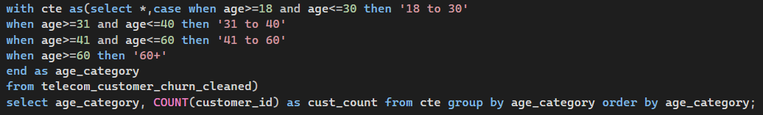
age_category | cust_count
18 to 30 | 1529
31 to 40 | 1288
41 to 60 | 2564
60+ | 1662
Through this we can understand that 41 to 60 age category customer is the most and surprisingly, the 60+ category leads more than 18 to 30 and 31 to 40 category.
The Telecom’s reach is very less to these categories(18 to 30 and 31 to 40).
When I calculated the count of customers, I could able to see the customers present in 1106 cities, and I have listed and shown the top 5 cities based on customer count.
City | Customer_Count
Los Angeles | 293
San Diego | 285
San Jose | 112
Sacramento | 108
San Francisco | 104

Here, we have the column has phone_service and Internet_Service which denotes the people who has chosen the service or not through 0 and 1.(0 means no opted 1 means opted)
Phone_Service:
Phone_Service | Customer_Count | User_Percent(%)
1 | 6361 | 90.316626437597
0 | 682 | 9.683373562402

Internet_Service:
Internet_Service | Customer_Count | User_Percent(%)
1 | 5517 | 78.333096691750
0 | 1526 | 21.666903308249

When we analyzed the count of customers who have opted both Phone and Internet service we have get to know that of 4835 people were subscribed or using the both the services.
Customer_Count | User_percentage_(%)
4835 | 68.649723129348

It is good to know that around 69% of people were using both the services.
One of a requirement is find the dervice users based on their age categories and the insights have been shown as:
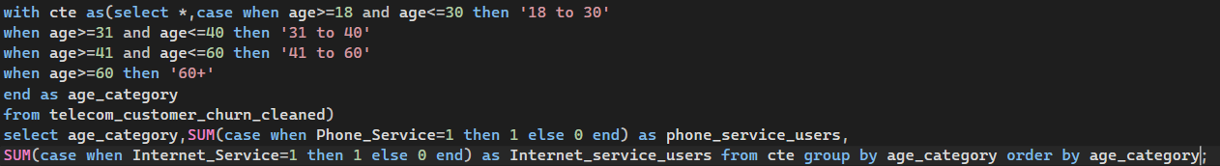
age_category | phone_service_users | Internet_service_users
18 to 30 | 1377 | 1155
31 to 40 | 1163 | 973
41 to 60 | 2313 | 1912
60+ | 1508 | 1477
Through this, we can get to know that 41 to 60 category of people leads the list with more number of Phone and Internet users and as expected 60+ category customers were also leads in the list and from these insights we can note a pattern that our service were primarily handled used by the 40+ age category people and was well received from there end.
When we analyzed the average tenure months of the employees it shows that the values are close to 32 across all age categories.
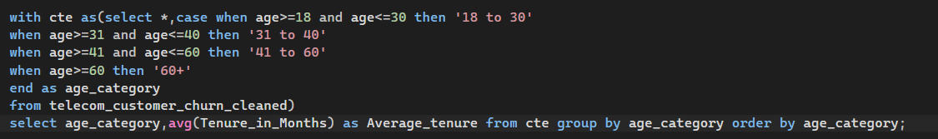
Age_category | Average_tenure
18 to 30 | 32
31 to 40 | 31
41 to 60 | 32
60+ | 32
Since, I didn’t get the information of start of the company, I will assume that the company has shared the last 3 year records or it was established or started 3 years back(Just for an assumption for now).
We proceeded to find top 5 cities based on revenue, we have got the following citie based on the ranks and given as follows:
City | Total_Revenue
Los Angeles | 852725.228790283
San Diego | 738416.010723114
Sacramento | 353371.838983536
San Jose | 326478.357017517
San Francisco | 306995.989040375

These cities where contributing well in our telecom business as well as these cities are one of the best contributors in economic as well.
Since we know 5517 customers opted for Internet Service, lets analyze and find the type of internet service they have opted for.
Internet_type | Customer_count | Overall_Contribution
Cable | 830 | 15.044408192858
DSL | 1652 | 29.943810041689
Fiber Optic | 3035 | 55.011781765452

From this, we can understand that Fiber Optic as outperformed in this and Customer Prefer this for their seamless experience.
Lets see the contract type opted by the customers for the plan.
Contract | Customer_count
Month-to-Month | 3610
One Year | 1550
Two Year | 1883

When we analyzed the average usage of the internet service based on the Internet Type we have seen:
Internet_Type | Avg_Usage
Fiber Optic | 25.0088962108731
Cable | 27.8722891566265
DSL | 27.5145278450363

From the insight, we received it shocks that though 55% of people opted for Fiber Optic Service but the average usage is low when compared to other two types of service.
Lets analyze the current status to know whether they stayed or canceled the service.
Customer_Status | Customer_count | Overall_Percent_
Churned | 1869 | 26.536987079369
Joined | 454 | 6.446116711628
Stayed | 4720 | 67.016896209001

From the analysis, we come to know that around 27% people have not returned or not opted for subscription, hence considered as left the service offered.
Lets analyze the churn category, to know the reasons that have mentioned.
Churn_Category | Customer_Count | Overall_Percent
Attitude | 314 | 16.800428036383
Competitor | 841 | 44.997324772605
Dissatisfaction | 321 | 17.174959871589
Other | 182 | 9.737827715355
Price | 211 | 11.289459604066
From this we could analyze that majority of the Customers have opted out due to the competitor, here we get the responsibility to know the reason or gap due to which they move towards. It is shocking to see around 17% opted for attitude and Dissatisfaction in which we lost around 34% of customers solely on our behaviour and response towards our customers for their concerns. This is truly shocking and non- barable reason for this. It pushes us to make force changes in the communication and service department.

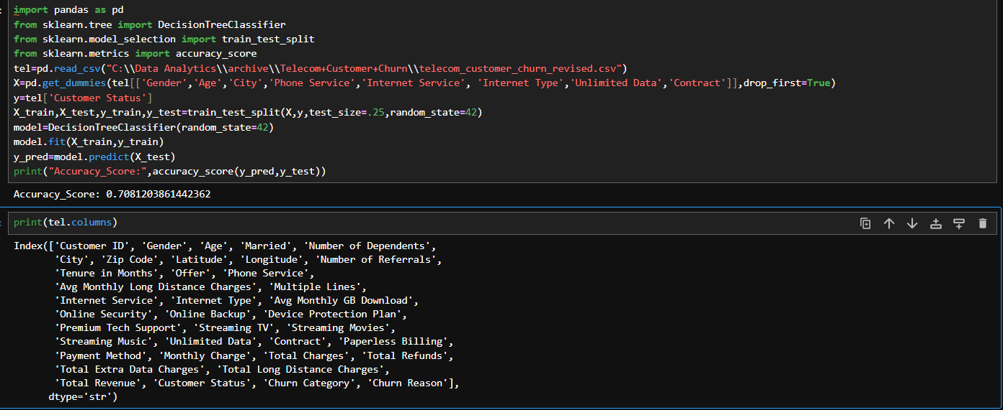
Next, inorder to know or predict if the customer may stay or leave the company, our intent is to create a ML model, so that it would be helpful for our purpose to track or omit on it. So, the code mentioned above is the one we written for creation and for it, we have got the accuracy score close to 71%. Lets try to improve the accuracy score as max as possible, but to make sure it doesn’t memorize the data instead.
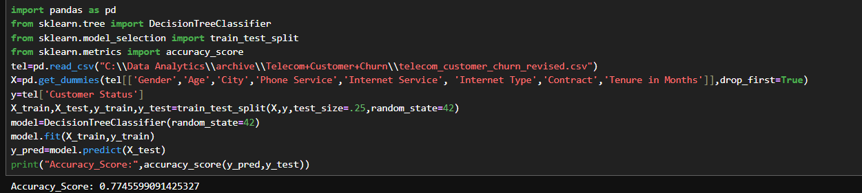
Initially the point came to mind is whether for any weak input features and inorder to make sure that I have added ‘Tenure of Months’ column into the X parameter and as expected I have seen a improvement score of 77.45% improvement. Also I removed the ‘Unlimited Data’ column as I tested and without that there is no change in score value.

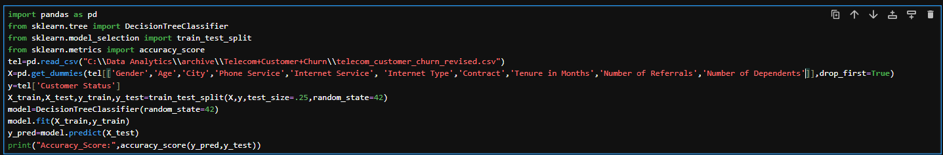
After further inclusion and exclusion of features in input I could able to reach to the score 80.3% which high when compared to the first score.
Upon next, we have tried with controlling in leaf and depth nodes.
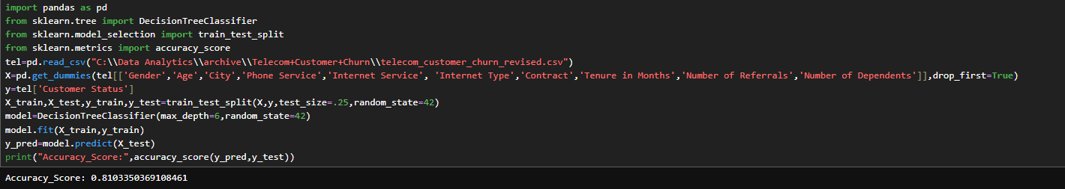
By adjusting the depth from 3 to 7 at depth=6, we have got improved in the accuracy score to 81%.
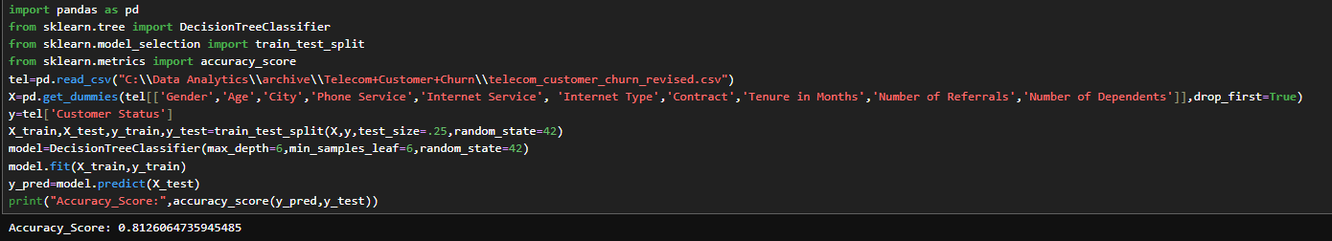
Similarly by adjusting the min_samples_leaf between 3 to 8 at 6 and 7 I have got the highest score of around 81.3% since for the better and fast process I have chosen 6 in that place.
Also for my understanding I have tried to create a model with RandomForestClassifier, and unexpectedly the score got improved to the mark of 82.96% which was good score.
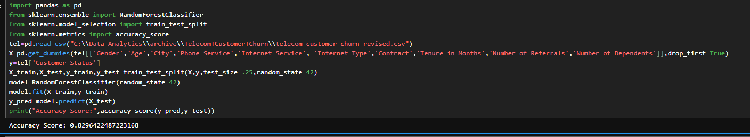
When I added n_estimators I have got good improvement in score, but when I added other parameters like max_depth and max_leaf_nodes it got dropped to 68%.
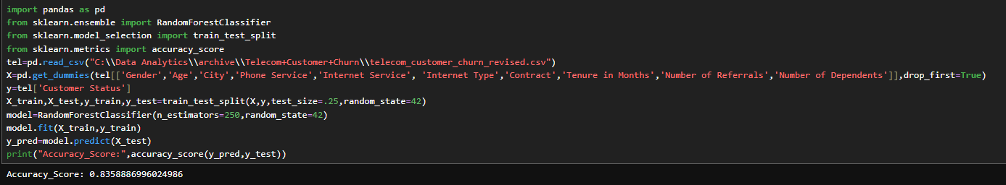
We need to decide the model depending on overfitting and in terms of RandomForestClassifier the model performs well in training data but less in testing data. Hence we could conclude that model is overfitting. Similarly, when we tested the same for DecisionTree the scores were very close.
So, considering this parameters I have decided to stay with decisiontree and use the model rather than going with overfitting model.
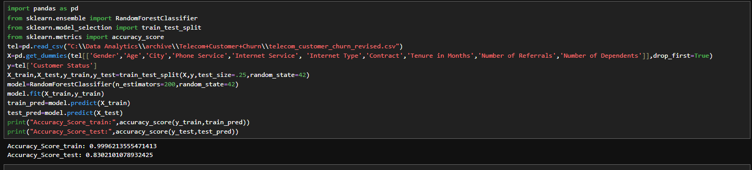
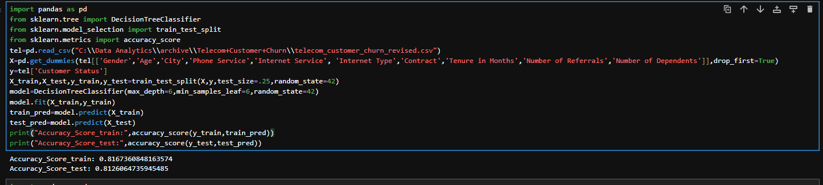
From these comparison, we can confirm that DecisionTreeClassifier outplayed in this aspect and we have chosen this model(DecisionTreeClassifier) for predicting our future endevours.

